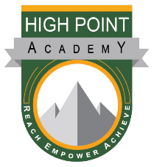
Parent’s Night Out Registration 2024-2025
- We will keep it on file for the year! You only need to fill out 1!!
High Point Academy

Child 1 Name: _________________________ Age: ______________
Child 2 Name: _________________________ Age: ______________
Child 3 Name: _________________________ Age: ______________
Address: ___________________________________________________
City: _____________________ State: _______ Zip Code: ____________
Guardians’ name: ___________________________________________
Guardian’s Phone: ___________________________________________
Emergency Contact: _________________________________________
Emergency Contact Phone: ____________________________________
Allergies/Health Concerns: ____________________________________________________________________________________________________________________
I/we the undersigned hereby certify that I/we are the legal guardian(s) of _____________________________________________________. I/we hereby give permission for the Parent’s Night Out Staff of High Point Academy to seek appropriate medical attention for the named child if needed. I/we can be reached at the telephone numbers given above. If I/we are unable to be reached at the provided numbers and medical treatment is needed, I/we give consent for such treatment to be administered. I/we will be responsible for any and all medical attention, transport, and treatment cost. I/we hereby release and discharge High Point Academy and all staff from any liability claim, cause of action, demand for damages or injury of any kind to my child or property as a result of participating in the of Parents Night Out camp at High Point Academy. I/we agree to allow the named child to participate in the Parents Night Out Camp activities including but not limited to: Viewing of G/PG rated movies, painting or other art projects, storytelling, etc.

Signature: _______________________________________________________Date: ________________

